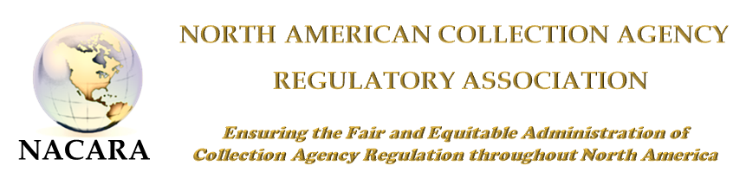

CALL FOR PRESENTATIONS
The North American Collection Agency Regulatory Association invites you to share expertise and experience with regulators and industry.
25th Annual Training Meeting - Downtown Charleston, SC
October 14-17, 2018
Deadline: Submissions are due on or before June 15, 2018 to Kelly Mack- kelly.mack1@maryland.gov

Programming Focus:

The following content area has been selected as an area of focus:
Medical debt/Veterans/Senior Affects, Revenue Cycle Management, 501C R- nonprofit hospitals

Audience
Educational sessions can range in audience size from 50-60 and audience skill levels vary as much as the diverse membership.
Presentation Day 1 will only be members of NACARA consisting of investigators, examiners, directors, collection agency board members and Assistant Commissioners and/or other regulatory management
Presentation Day 2 will be members of NACARA as well as collection agency industry officers, owners, directors, counsel, and compliance officers
Presentation Selection
All presentation proposals received on or before June 15, 2018, will be reviewed by the NACARA Education Committee. Selection will be determined on appropriateness and interest of topic, level of content, comprehensiveness of session objectives and expertise of presenter. Presentations may be submitted for day 1 or day 2 or both; please indicate any preference for presentation audience. NACARA reserves the right to make recommendations for revisions of content within proposals prior to acceptance. Participation as a presenter is by invitation only after review of the proposal. Presenters will be notified only of their acceptance.

Responsibilities
All presenters are required to submit their final presentation to the NACARA Education Committee 30 business days prior to the conference for publication on the NACARA website or for a post-conference CD (if offered). These materials, as well as handouts, are always requested by our attendees who need to reference presentations prior, during, and after the conference to enhance their education.

NACARA’s Non-Commercial Policy
Participants in NACARA programs are seeking valuable educational sessions and are always critical of presenters or sessions that are self-promotional. NACARA policy therefore obliges presenters may not use a conference session for commercial sales pitches, self-promotion, or unwarranted criticism of a competitor. Presentations should only advance the educational process; sales pitches do not and are, therefore, not acceptable. Speakers are not permitted to distribute company promotional literature, brochures, or sales materials in any form to attendees during their session.
NACARA Reimbursement Policy
The NACARA Executive Committee believes that it is an honor to be invited to participate in programs contributing to the professional training of NACARA members. A non-member speaker attending the training conference is not required to register; however NACARA will not reimburse for other travel expenses including, but not limited to, flight, hotel, food, drink and taxi/Uber etc.

Presentation Application
Speaker Contact Information
Name:
Title:
Company: ______
Address:
City, State, Postal Code: _______________________________________
Telephone: _______________________________________
Email: ____________________________________________________

Co-presenter Information:
Name:
Title:
Company: ______
Address:
City, State, Postal Code: _______________________________________
Telephone: _______________________________________
Email: ____________________________________________________

Presentation Title (10 words max): ______ ______
Presentation Description (focus statement):
Please describe your session in three sentences; explaining session content and overall objective. This description should be creative and reflective of learner outcomes and session objectives.

Learner Objectives / Outcomes:
List the instructional objectives (what the audience should know or be able to do as a result of the presentation). Please provide at least two.

1)

2)

3)

4)

Presentation Level / Format:
All subject matter must be at the advanced/expert level for the summit.

Please indicate your target audience:
NACARA members Industry Other: _____________________________

Please select the number of proposed presenters:
Sole presenter Panel (3+) presenters Speaker & Facilitator

Please select the closest representation of the format and style of your presentation:
100% one-way delivery of information 50-50% content-interaction 100% audience interaction
Previous Presentations/References
List at least three presentations you have made including date made, presentation title, audience and size of audience. If you do not have three presentations you have made, please list the name of three individuals who can speak directly about your presentation abilities:

1. ________________________________________________________________________________________
2. ________________________________________________________________________________________
3._________________________________________________________________________________________

By signing the application, I submit my presentation for consideration and will comply with NACARA's responsibilities and non-commercial policy.

(only signed submissions can be considered) Date

If presenting on Day 1 – non-member presenters will only be allowed in meeting rooms during presentation hours and not the whole day, but may stay for day 2 which will include industry.

