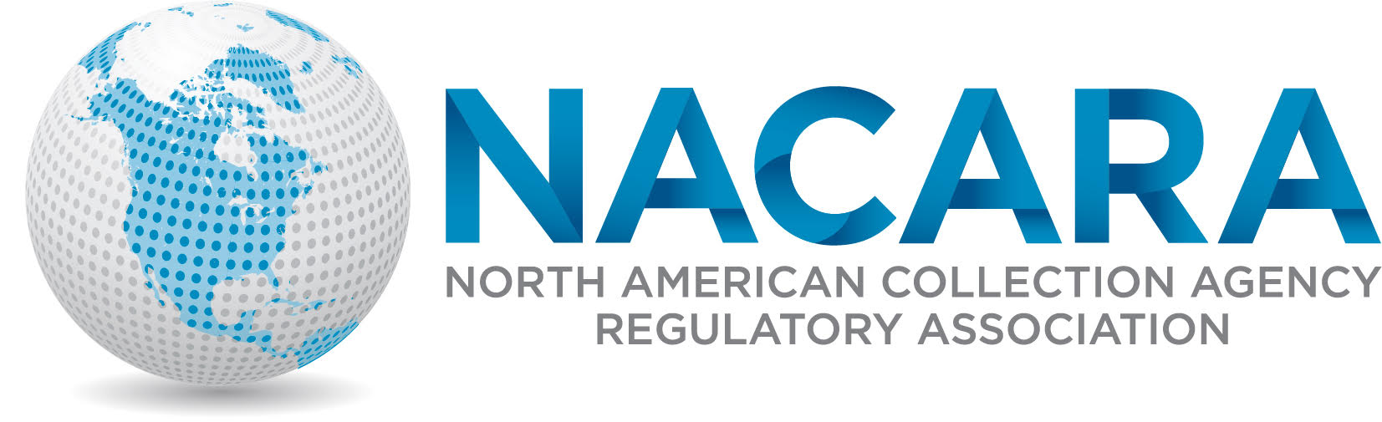
2019 NACARA ANNUAL CONFERENCE & TRAINING EVENT

AGENDA
September 16th-18th, 2019
Eldorado Hotel & Spa – Santa Fe, New Mexico
Monday, September 16, 2019 – Regulators Only

7:00 – 8:00am | Registration
8:00– 8:30 | Welcome & Opening Remarks  Elizabeth Benotti (President of NACARA) & Christopher Moya, Director, Financial Institutions Division, New Mexico Regulations and Licensing Department
8:30 – 9:30 | Federal Trade Commission Update  Tom Carter, Senior Attorney (FTC)
9:30 – 9:45 | Break
9:45-10:15 | Nationwide Multistate Licensing System (NMLS) Update  Tim Doyle, Senior Vice President - CSBS
10:15-11:00 | License Wizard Demonstration  Bill Young, NMLS Business Services Vice President, CSBS
11:00-12:00pm | Licensing Consultants Panel  “Services and Value”  Christy Young-Barger, Director of Risk Mgmnt. – Cornerstone &  Tim Lange, COO, Buckley, Sandler, LLP
12:00 – 1:00 | LUNCH
1:00 - 2:00 | “Offshore Collections: Regulatory Considerations”  Manny Newburger, Esquire – Barron, Newburger & Sinsley, PLLC
2:00 - 3:00 | CSBS Policy Update  Mary Pfaff, Sr. Director – Legislative Policy, CSBS
3:00-3:15 | Break
3:15–4:15 | Business Meeting & NACARA Elections
4:15-5:00 | Regulator Roundtable – Part I  Jedd Bellman (Vice President of NACARA) – Moderator
5:00-8:00 | Regulator only Function*  Meow Wolf Art Museum & Group Dinner@  Second Street Brewery’s Rufina Taproom
Tuesday, September 17, 2019 - Regulators and Industry
8:00-9:00am | Registration & Meet the Regulator Breakfast
9:00 – 10:00 | The Consumer’s Journey Through Credit, Collection and Artificial Intelligence Technology - What’s Coming”  Stephanie Eidelman, CEO iA Institute – Moderator
10:00-10:15 | BREAK
10:15 – 11:00 | True Accord – Machine Learning Process  Kelly Knepper-Stephens, Vice President &  Sophie Benbenek, Head of Data
11:00– 12:00pm | General Session  Student Loan Servicing & Debt Collection  Chuck Cross, Moderator- CSBS  Panelists  Melinda Lee, Dept. of Business Oversight (CA)  Cindy Fazio, Chief Regulatory Affairs (WA)  Brad Fletcher, Consumer Services Mgr.-Student Loan Servicing (KS)
12:00-1:00 | Lunch
1:00-2:00 | Consumer engagement –  The Law, The Rule and Challenges  Rozanne Andersen, Vice President, CEO Ontario Systems, LLC
2:00-2:45 | General Session  Artificial Intelligence, Myths, Marketing, Pitfalls & Positives  Gregory Allen, CEO - Pairity
2:45-3:00 | Break
3:00-4:00 | Privacy data Security I and II  Leslie Bender, CSO and General Counsel – BCA Financial Services & Debra Ciskey, Executive Vice President, Collection Coach, LLC
4:00-5:00 | General Session  Debt Collection Update  Andy Madden, Vice President – ACA International
5:00-8:00 | Networking Reception – Industry & Regulators
Wednesday, September 18, 2019
8:00 – 9:00am | BREAKFAST  Regulators & Industry
9:00- 10:00 | Bureau of Consumer Financial Protection Update  New Debt Collection Rule  John McNamara, Asst. Director- Consumer Lending  Regulators & Industry
10:00-11:00 | Nonbank Cybersecurity Examination Program/Cyber 101  Chuck Cross, Sr. Vice President, CSBS  Regulators & Industry
11:00- 12:00pm | Regulator Roundtable – Part II  Regional Group Sessions  Regulators Only  Jedd Bellman (Vice President of NACARA) - Moderator
12:00 | Adjourn – Travel

Open to NACARA Members, Regulators, and Regulatory Affiliates only
Open to NACARA Members, Regulators, Regulatory Affiliates, and Industry

