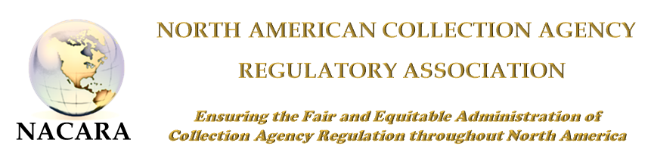
2018 NACARA ANNUAL CONFERENCE & TRAINING EVENT
AGENDA
October 15 - 17, 2018
Holiday Inn – Downtown Charleston - Charleston, SC
Monday, October 15, 2018 – Regulators Only*
7:00 – 8:00 | Registration
8:00 – 8:30 | Welcome & Opening Remarks  Elizabeth Benotti (President of NACARA) and Carrie Grube-Lybarker (South Carolina Dept. of Consumer Affairs Administrator)
8:30 – 10:30 | Kinesic Interview and Interrogation – Part II  Christopher Holland (Holland & Associates)
10:30 – 10:45 | Break
10:45 – 12:00 | General Session – Multi-State Examinations, Multi-State Debt Collection Committee, & State Examination System  Anthony Polodori (Idaho) and Tony Vasile (CSBS)
12:00 – 1:00 | Lunch
1:00 – 2:00 | General Session – Eldercare & Debt Collection  Anthony Salazar (Maryland Commissioner of Financial Regulation)
2:00-3:00 | Federal Trade Commission Update  Tom Carter (FTC)
3:00 – 3:15 | Break
3:15 – 4:00 | Business Meeting & NACARA Elections
4:00-5:00 | Regulator Roundtable – Part I  Jedd Bellman (Vice-President of NACARA) - Moderator
5:00-8:00 | Regulator Dinner*
Tuesday, October 16, 2018 - Regulators and Industry
8:00-9:00 | Registration & Meet the Regulator Breakfast
9:00 – 9:45 | General Session – Licensing Board Discussion:  Similarities/Differences/Authorities/Board Make-Up  Peggy Matson (AR), Bradley Chapman (WY), and Grace Hamilton (WA)
9:45 – 10:45 | debt collection industry update
10:45 – 11:00 | Break
11:00– 12:00 | “Understanding Alzheimer Disease and How It Relates to Debt”  Sam Wiley (VP of Programs, Alzheimer’s Association)
12:00-1:00 | Lunch
1:00-2:00 | Unraveling Healthcare Compliance  Leslie Bender
2:00-3:00 | General Session  How Technology Is Changing the Collections Terrain  Tim Lange and Kathryn L. Ryan, Buckley Sandler, LLP
3:00-3:15 | Break
3:15-4:15 | General Session – Student Loan Servicing & Debt Collection  Chuck Cross (CSBS) Stacey Serrano (CT)
4:15-5:00 | Nationwide Multistate Licensing System (NMLS)/Vision 2020  Tim Doyle (CSBS)
5:00-8:00 | Networking Reception – Industry & Regulators
Wednesday, October 17, 2018 – Regulators Only and Industry*
8:00 – 9:00AM | Legislative Update, etc. Title TBD  Manny Newberger
9:00 – 10:00 | COMMERCIAL COLLECTION OF AMERICA - TBD  Manny Newberger and Annette Waggoner
10:00 – 11:00 | General Session –  Bureau of Consumer Financial Protection (CFPB) Update tbd
11:00-12:00 | Regulator Roundtable – Part II*  Jedd Bellman (Vice-President of NACARA) - Moderator
12:00 PM | Adjourn – Travel

*Industry will not be included in this session

